Multi-Level Anomaly Detection in Financial Transactions: A Comparative Study of Machine Learning and Deep Learning Models
Quarterly Report 1: Foundation and Data Preparation

Siddartha Bandi
College of Engineering & Mines, University of North Dakota
Grand Forks, ND, USA
siddartha.bandi@und.edu
Course: DATA 994 – Capstone Project | Instructor: Dr. Marina E. Kim

Abstract
This quarterly report documents the first phase of the capstone project: a comparative study of five models for multi-level anomaly detection in financial transaction data. The first phase focused on three areas: (1) an extended literature review covering five model families and hierarchical classification frameworks; (2) exploratory data analysis (EDA) of the Kaggle Credit Card Fraud Detection dataset; and (3) the complete data preprocessing pipeline, including SMOTE-based class balancing, multi-level label engineering for a hierarchical two-stage detection framework, and time-window sequence construction for the LSTM model. The preprocessed dataset is now ready for the model implementation phase in Quarter 2.

Keywords—fraud detection, anomaly detection, machine learning, deep learning, SMOTE, class imbalance, hierarchical classification, financial transactions

I. INTRODUCTION
Financial fraud detection represents one of the most challenging problems in applied machine learning: the data is structurally imbalanced, the patterns evolve rapidly, and the cost of both false negatives (missed fraud) and false positives (wrongly flagged legitimate transactions) is high. This project addresses the problem by designing and evaluating a hierarchical two-stage detection framework that first identifies anomalous transactions (Level 1: binary classification) and then stratifies those anomalies by risk severity (Level 2: multi-class risk scoring).
This report covers the work completed in Quarter 1: an extended literature review, full exploratory data analysis of the selected dataset, and a complete preprocessing pipeline including SMOTE rebalancing, multi-level label engineering, and LSTM sequence construction.
II. LITERATURE REVIEW

A. Supervised Ensemble Methods
Random Forest [1] has long served as a strong baseline for tabular fraud detection due to its robustness to noise and built-in feature importance reporting. XGBoost [4], introduced by Chen and Guestrin as a scalable gradient boosting system, has consistently outperformed Random Forest on structured tabular datasets while offering native class-imbalance handling through its scale_pos_weight parameter and direct support for multi-class objectives.
B. Unsupervised Anomaly Detection
Isolation Forest [3] detects anomalies by measuring how few random partitions are required to isolate a data point. Genuine anomalies are isolated in fewer partitions than normal points, yielding an anomaly score that does not require labeled training data. This is particularly valuable for detecting zero-day fraud patterns absent from historical records.
C. Deep Learning for Anomaly Detection
Autoencoders [7] address fraud detection by learning a compressed latent representation of normal transaction patterns. High reconstruction error on an unseen transaction signals deviation from learned normal behavior. LSTM networks [5] extend this to the sequential domain: by treating a customer's transaction history as a time series, LSTMs can detect behavioral anomalies that are invisible when transactions are evaluated in isolation.
D. Class Imbalance and SMOTE
The literature consistently identifies class imbalance as a primary obstacle in fraud detection [2][6]. SMOTE generates synthetic minority class samples by interpolating between existing fraud examples in feature space, preventing classifiers from converging to the trivial solution of predicting all transactions as legitimate.
E. Hierarchical and Multi-Level Classification
Recent work in financial security has moved toward risk-tiered detection frameworks that assign severity levels to flagged transactions, enabling security operations teams to prioritize their response. This project contributes to this direction by implementing a two-stage pipeline across all five models.
III. DATASET AND EXPLORATORY DATA ANALYSIS
A. Dataset Description
This project uses the Credit Card Fraud Detection dataset publicly available on Kaggle [1]. The dataset contains 284,807 credit card transactions made by European cardholders over two days in September 2013. Of these, 492 transactions (0.172%) are fraudulent, representing a severe class imbalance ratio of approximately 578:1. The dataset contains 30 features: 28 PCA-transformed numerical features (V1 through V28), along with the original Time and Amount features. The target variable Class takes the value 1 for fraud and 0 for legitimate transactions.
B. Key EDA Findings
Exploratory analysis revealed several important characteristics of the dataset. Fig. 1 presents a collage of key EDA visualizations.
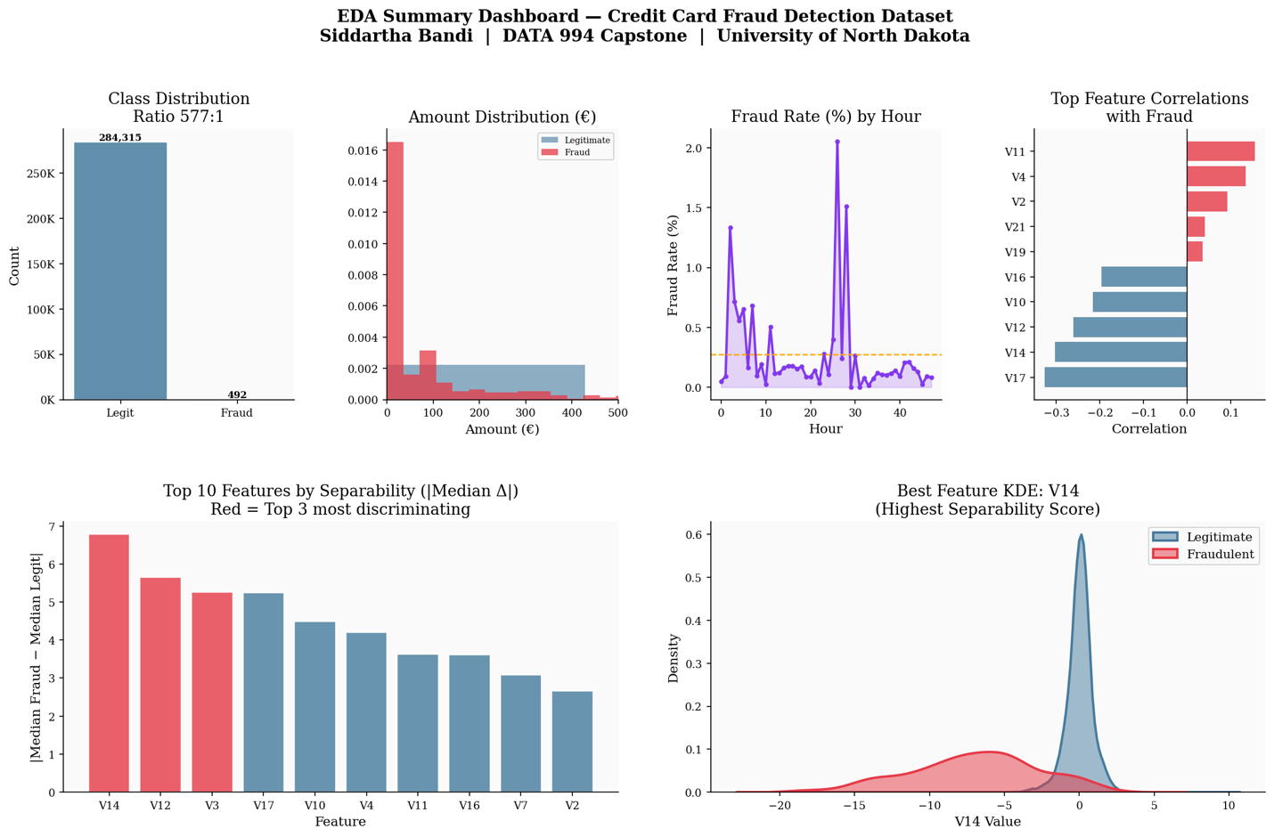
Fig. 1. EDA collage: class distribution, amount distributions, temporal patterns, and feature separation analysis for the Credit Card Fraud Detection dataset.
Transaction Amount: Fraudulent transactions tend to cluster at lower amounts (median approximately €122) compared to legitimate transactions (median approximately €22), with a long tail of high-value fraud events. Temporal Patterns: Fraud occurs across all time windows, showing a slight relative elevation during off-peak hours. Feature Distributions: PCA features V4, V11, V14, and V17 show strong separation between the fraud and legitimate classes. Correlation Structure: No significant multicollinearity is present among V1-V28 features.
IV. DATA PREPROCESSING PIPELINE
A. Standard Scaling
The Time and Amount features were standardized using Scikit-learn's StandardScaler to bring them onto the same scale as the PCA-transformed V1-V28 features. Scaling was fit exclusively on the training split and applied to both training and test sets to prevent data leakage.
B. Train/Test Split
The dataset was split into 80% training and 20% test sets using a stratified split to preserve the original fraud ratio in both partitions. This yields approximately 227,845 training transactions and 56,962 test transactions.
C. SMOTE Implementation
SMOTE was applied exclusively to the training set following the train/test split to prevent synthetic samples from influencing evaluation. The imblearn library implementation was used with k=5 nearest neighbors. After SMOTE, the training set contains a balanced 50/50 distribution, providing supervised models with sufficient fraud examples to learn meaningful decision boundaries.
D. Multi-Level Label Engineering
The hierarchical two-stage framework requires two label sets. Level 1 labels retain the original binary classification: 0 (Normal) and 1 (Anomalous). Level 2 risk tier labels are engineered from the training data using a threshold-based scheme: Low Risk (anomaly confidence score in the lower tercile), Medium Risk (middle tercile), and High Risk (upper tercile, corresponding to high-confidence fraud predictions).
E. LSTM Sequence Construction
The LSTM model requires sequential input rather than individual transaction records. Sequences were constructed using a sliding time-window approach: transactions within each 60-second window are grouped into sequences of fixed length (window_size = 10 transactions). Sequences containing fewer than 10 transactions are zero-padded, yielding a 3D input array of shape (samples, 10 timesteps, 30 features).
V. PROGRESS SUMMARY AND NEXT STEPS
Quarter 1 deliverables have been completed as planned. The preprocessed dataset, SMOTE-balanced training split, multi-level label framework, and LSTM sequences are all ready for model implementation. The following tasks are planned for Quarter 2:
(1) Implement and tune Random Forest and XGBoost classifiers on SMOTE-balanced training data.
(2) Implement Isolation Forest for unsupervised anomaly detection on the unbalanced dataset.
(3) Design and train the Autoencoder architecture using TensorFlow/Keras on legitimate transactions only.
(4) Design and train the LSTM architecture using the sequence-formatted dataset.
(5) Record Level 1 binary classification metrics (Precision, Recall, F1, AUPRC) for all five models.
VI. CONCLUSION
Quarter 1 successfully established the foundational components for the project's comparative analysis. The literature review confirmed that class imbalance and the choice between supervised and unsupervised approaches are the central challenges in financial fraud detection. EDA confirmed that the selected dataset exhibits severe class imbalance and that several PCA features provide strong discriminative power. The complete preprocessing pipeline—including standard scaling, stratified splitting, SMOTE rebalancing, multi-level label engineering, and LSTM sequence construction—is documented and ready for Quarter 2 model implementation.
REFERENCES
[1] A. Dal Pozzolo, G. Boracchi, O. Caelen, C. Alippi, and G. Bontempi, “Credit card fraud detection: A realistic modeling and a novel learning strategy,” IEEE Trans. Neural Netw. Learn. Syst., vol. 29, no. 8, pp. 3784–3797, Aug. 2018.
[2] N. V. Chawla, K. W. Bowyer, L. O. Hall, and W. P. Kegelmeyer, “SMOTE: Synthetic Minority Over-sampling Technique,” J. Artif. Intell. Res., vol. 16, pp. 321–357, Jun. 2002.
[3] F. T. Liu, K. M. Ting, and Z.-H. Zhou, “Isolation forest,” in Proc. 8th IEEE Int. Conf. Data Mining (ICDM), Pisa, Italy, 2008, pp. 413–422.
[4] T. Chen and C. Guestrin, “XGBoost: A scalable tree boosting system,” in Proc. 22nd ACM SIGKDD Int. Conf. Knowl. Discovery Data Mining, San Francisco, CA, 2016, pp. 785–794.
[5] S. Hochreiter and J. Schmidhuber, “Long short-term memory,” Neural Comput., vol. 9, no. 8, pp. 1735–1780, 1997.
[6] S. Makki, Z. Assaghir, Y. Taher, R. Haque, M.-S. Hacid, and H. Zeineddine, “An experimental study with imbalanced classification approaches for credit card fraud detection,” IEEE Access, vol. 7, pp. 93010–93022, 2019.
[7] M. Sakurada and T. Yairi, “Anomaly detection using autoencoders with nonlinear dimensionality reduction,” in Proc. MLSDA 2014 2nd Workshop Mach. Learn. Sensory Data Anal., Gold Coast, Australia, 2014, pp. 4–11.
[8] E. O. Ounachad, B. Ouadid, and A. Hasbi, “Deep learning for fraud detection in financial transactions: A survey,” in Proc. 2020 IEEE Int. Conf. Technol. Manag., Operations Decisions (ICTMOD), Marrakech, Morocco, 2020, pp. 1–6.

